A Proposal for advanced scintillation detector development

J. Blazey, A. Bross, K. Mellott, A. Pla-Dalmau

Table of Contents

1. Charter 4
2. Core Program 4
1. Plastic Scintillator R&D 4
2. Extruded Scintillator R&D 5
1. Introduction 5
2. Overview 6
3. Full Scale Proof of Principle Test of In-line Extrusion 8
4. Rationale for In-House Facility 9
5. Potential Uses for the facility 10
6. R&D Opportunities 11
7. Equipment Definition and NICADD Contributions 12
3. Connectors and optical coupling 12
4. Photo detector R&D 12
1. VLPC Development 12
2. Other Solid-State detectors 13
3. Test Stands 13
5. Ultra High Speed Timing Techniques 13
6. Interdisciplinary Activities 14
7. Students 14
8. Industrial Connection 14
9. Staffing 15
10. Siting 15
1. Lab 5 15
2. Lab 6 16
3. Lab 7 17
4. Summary 18
11. Conclusion 18
12. Appendix 1 - Extrusion Line Cost Breakdown 19
13. Appendix 2 - Extrusion Line Specifications and Requirements 20
1. Introduction 20
2. Technical Requirements: 20
1.0 Extruder: 20
2.0 Material Feed System: 22
3.0 Downstream Equipment: 23
4.0 Auxiliary Equipment: 25
5.0 Delivery, Installation, and Test: 26
6.0 Spare Parts: 27
7.0 Training: 28
8.0 Maintenance and Service Agreement: 28
9.0 Information and Documentation Management: 28
10.0 Warrantee: 29
11.0 OPTIONAL PROPOSALS: 29
15. Appendix 3 - Operating Budget for FY 2002 and 2003 30
14. Appendix 4 – Retrofit and Installation Costs 31
1. LAB 5 Retrofit and Installation Costs 31
2. LAB 6 Retrofit and Installation Costs 34
3. LAB 7 Retrofit and Installation Costs 37
16. Appendix 5 –Lab 5 Extrusion Line Floor Plan 40
17. Appendix 6 – Lab 6 Extrusion Line Floor Plan 41
18. Appendix 7 – Lab 7 Extrusion Line Floor Plan 42
19. Appendix 8 – Extrusion Line Feeder end Elevation View 43
20. Appendix 9 – Full Extrusion Line Floor Plan 44

1. Charter

The Fermilab Scintillator Detector Development Laboratory (SDDL) and the Northern Illinois Center for Accelerator and Detector Development (NICADD) will collaborate on the extension of the state-of-the-art in instrumentation for particle detectors for high-energy physics. The collaboration will focus on scintillation detectors, their readout, prototyping of advanced designs, and simulation. The groups will investigate scintillator detector physics and technology that will be relevant to a well-known set of detector applications: scintillating fiber tracking, wavelength shifting fiber readout of preshower, shower max, or calorimetric detectors, and fast timing techniques. The detector technology can be applied to a wide range of HEP detector applications from ultra-fine segmentation tracking devices to very large-scale (10X MINOS) neutrino detectors. The collaboration will strive to provide an integrated solution to HEP requirements by exploring new concepts in both scintillator design and in their readout.
The joint project will have a core group of physicists (staff, postdocs, and students), material scientists, engineers, technicians, and interdisciplinary coop students that will develop and test new detector concepts. This group will work closely with experimental groups in order to bring these ideas into the Fermilab (and US) HEP program as quickly as is possible and to help develop related detector concepts initiated by the experimenters themselves. Training of physicists in detector development will be a component of the collaborative effort. The laboratory will be able to provide support for prototyping experiment-specific detector designs and will also be able to support limited production runs (up to ≅ 50 tons in the case of extruded scintillator) in order to produce final detector components for approved experiments.
The detector and technology R&D program of this collaboration is an excellent match to the detector needs for experiments at existing facilities and those being considered for the future.

2. Core Program

1. Plastic Scintillator R&D

Plastic scintillation detectors have been used for many years in nuclear and high-energy physics experiments. New applications for plastic scintillators have resulted from recent developments in both plastic optical fibers and photon detection devices. This renewed interest in plastic scintillation materials has encouraged research towards the modification and improvement of their radiation resistance properties and fundamental characteristics such as, absorption and emission spectra, light yield and decay time.

Work on plastic scintillator R&D will be a continuation of the current efforts of the Fermilab Scintillator Detector Development Laboratory. These activities will include research on polymers, dopant synthesis, new scintillator formulations, and radiation damage effects.
This collaboration offers the opportunity to easily work with universities, mainly with the Chemistry and Engineering Departments, and benefit from their knowledge and experience to pursue new research goals. Some of the potential R&D projects are in the following areas:
- Dopant synthesis
  - Fast fluorescent compounds emitting at long wavelengths
  - Fluorescent compounds embedded in polymer matrix
- Dopant modeling prior to synthesis
  - Stability of the compounds
  - Prediction of absorption and emission spectra
- Materials Development
  - Commercial polymers
  - Additives
  - New polymers
- New plastic scintillator formulations
  - Metal-doped scintillator
    - Gd
    - Li
    - B
- Radiation damage studies
  - Additives
  - Hardening

2. Extruded Scintillator R&D

1. Introduction

Although plastic scintillator has been used in high-energy-physics experiments for over four decades, interest in this material has increased in the last decade due to the development of high-quality plastic optical fiber. This optical fiber can be undoped, or doped as scintillator or wavelength shifter. Wavelength shifting (WLS) fiber is now the favored method to readout plastic scintillation detectors essentially replacing all uses of “bent-acrylic” waveguides and wavelength shifting bars. Applications for this technique, WLS fiber readout of plastic scintillator plate includes counters, hodoscopes, preshower detectors, and calorimeters. This technique has reduced manufacturing costs while at the same time allowed for more complex detector geometries that yield better physics performance. The technique has now been used in many experiments with great success.

In 1993 as an outgrowth of proposal P860 members of the Scintillation Detector Development Lab considered the possibility of building a very large neutrino detector out of plastic scintillator. Even with WLS fiber readout, a 10-kton detector using plastic scintillator as the active detector was not affordable using conventional cast scintillator plate. It was proposed to try to develop an inexpensive extrudable polystyrene scintillator that could be based on commercial grade polystyrene pellets and commercial processing techniques. The R&D proved quite successful. Two preshower detectors for the D0 experiment have already been built using this technology. In addition scintillator extrusions similar to those used for D0 were produced for STAR, and the MINOS experiment has chosen the extruded scintillator technique and is currently in production. A patent application was filed in 1997 and was recently awarded. Although the process uses commercial techniques and equipment, the details of the production are, at present, quite delicate in order to produce high-quality scintillator.

2. Overview

Several factors contribute to the high cost of cast plastic scintillating sheets and drawn wavelength shifting fiber. The main reason is the labor-intensive nature of the manufacturing processes in these two cases. The raw materials such as styrene, vinyltoluene and dopants need to be highly pure. These purification steps often take place just prior to their utilization. Cleaning and assembly of the molds for the polymerization process is a detail-oriented operation that adds to the overall timeline. The polymerization cycle lasts for a few days. It consists of a high temperature treatment to induce full conversion from monomer to polymer and a controlled ramp-down to room temperature to achieve a stress-free material. Finally, there are machining charges for sheets and tiles, and drawing charges for fibers that cannot be overlooked. In order to significantly lower the cost of plastic scintillators, extruded plastic scintillation materials were considered.

The basic process takes a commercial grade polystyrene (PS) pellet and then mixes in or “compounds” primary and secondary dopants to produce a polystyrene scintillator which is then extruded or otherwise processed. This can be done in either one or two steps. The two-step process first compounds the commercial PS with the appropriate dopants and then re-pelletizes the resultant scintillator material. These scintillating pellets can then be further processed by extrusion or injection molding techniques to produce the desired scintillator shape. The one step process combines the compounding and extrusion into one step.

The two-step process is conducted at two separate facilities. Figure 1 depicts the flow chart for this method. The first step is carried out at a company whose function is to add the dopants to the polystyrene pellets (compounding). This compounding step is a batch process where polystyrene pellets and dopants (typically in 100 lb. batches) are tumble-mixed for 15 min. and then added to the hopper of the extruder. A silicone oil is used as a coating aid to achieve better distribution of the dopants on the pellets. An inert gas flow is also added to the hopper to minimize the presence of oxygen in the extruder. The die at the extruder head generates several “strings” of material that are pelletized yielding the scintillating pellets. At the end the scintillating pellets collected during the run are blended to homogenize the material. These pellets can now be used to produce plastic scintillators through several procedures - namely extrusion, casting, or injection molding. Using this batch process, there is also the possibility of directly extruding the scintillator profile in the same equipment thus bypassing the pelletizing step.

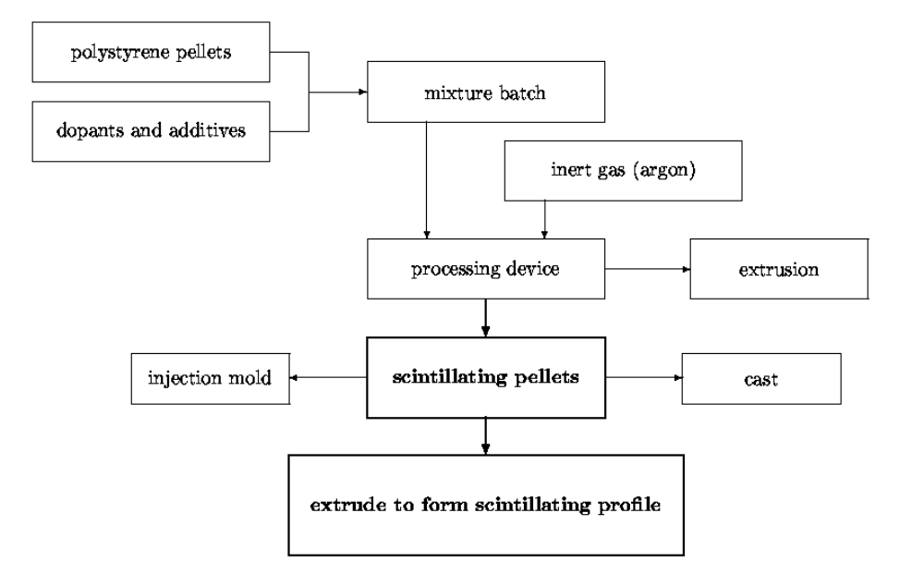

Figure 1. Two-Step process for scintillator extrusions

An alternative to these operations is given by Method 2, which is summarized in Figure 2. Method 2 is a continuous in-line compounding and extrusion process. It emphasizes the most direct path from polystyrene pellets to the scintillator profile with the least amount of handling of the raw materials. In this situation, the purged polystyrene pellets and dopants are metered into the extruder at the correct rate for the required composition of the scintillator. An inert gas flow is still used at the hopper. Coating agents are no longer needed. The appropriate die profile gives rise to the extruded scintillator form of choice. If the die can produce strands, these can also be pelletized and the scintillating pellets used in other processes. Method 2 has been tested and produces plastic scintillator of high quality and homogeneity. Although it is a simple concept, the equipment to accurately meter small quantities of powders such as the dopants and to achieve a good distribution of the powders in the molten polymer is not widely available.

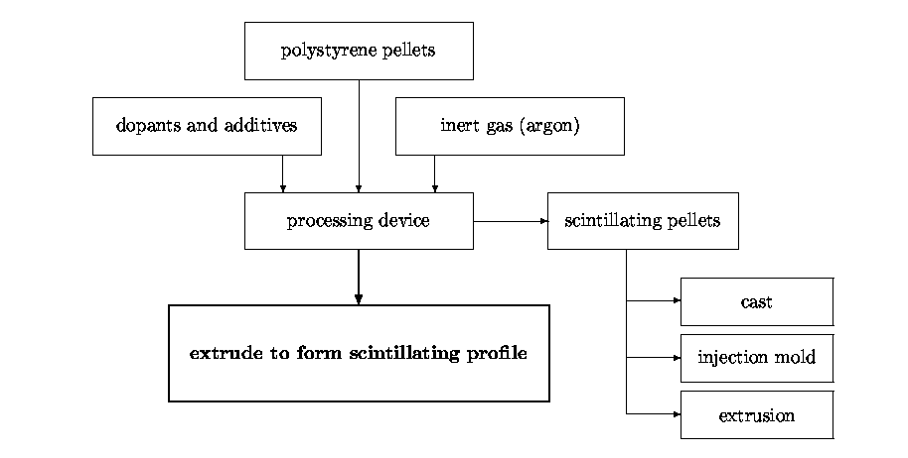

Figure 2. In-line extrusion

3. Full Scale Proof of Principle Test of In-line Extrusion

Although we have done an in-line extrusion test at Leistritz America, we felt that a more comprehensive test was required before developing the final specifications for an extrusion line. We contacted 3 vendors in regard to doing this type of test at their facilities. Of these only Krupp Werner & Pfleiderer (KWP) had the required facilities. However even in their case, in the end we had to rent from a third source some of the downstream equipment that was needed for the test. The main goal of this trial was to test KWP’s 40mm twin-screw extruder as both an R&D and prototype production machine using our benchmark 1 X 2 cm profile with central hole for a WLS fiber. It was also our desire to gain knowledge regarding feeders, vacuum sizers, and other related extrusion equipment while at the KWP test lab and to test run our new 10-hole die using the direct extrusion method. The tests were to include exploration of the machine/line capability including both profile and pellet scintillator production at various throughput speeds and configurations, with collected samples tagged for possible later analysis at Fermilab.
Necessary materials, tools and equipment were shipped by truck the week prior to the run and then Anna Pla-Dalmau and Kerry Mellott flew out early Monday morning with arrangements to stay for the week and oversee the trial. For the next three and one half days we worked with the KWP crew and engineers to accomplish our stated goals.
We were able to easily achieve 200 lbs/hr throughput with the 1 X 2 cm part. No instability was detected and a significant reserve in extruder and melt pump capability remained. This indicates even higher rates are possible with this part, but were not achievable in this test because our melt pump adaptor was missing a pressure port to monitor the melt pump pressure and the cooling tank was not long enough to effectively cool the part at higher rates. Other problems involved the feeders and their connection to the extruder. Although a special feed configuration was arranged for this test, the feed stream was not absolutely inert and oxygen readings were in the low percent range rather than the required ppm range. This, along with color contaminants from previous lab trials, reduced the light yield of the collected samples. Contamination from previous operations is often a problem and clearly demonstrates that even very experienced vendors come up against a very steep learning curve (even when we help, see below) when it comes to producing high-quality plastic scintillator.

Overall, the run proved the 40 mm extruder capable of producing scintillator using the direct (inline) method at rates between 50 and 300 lbs/hr with apparent reserve to exceed the upper test limit by a considerable margin. (Pellets were produced at 300 lbs/hr and two different profiles at 200 lbs/hr with torque never greater than 50%.). Problems with residual oxygen and particulate contamination were problems specific to the test at KWP’s facility and are not inherent in the equipment and will not be present with a system setup at Fermilab.

4. Rationale for In-House Facility

Although the processes described thus far can be done at many commercial compounding or extrusion vendors, there are a number of subtleties involved with the fabrication and our experience to date has raised a number of concerns in going this route. First none of the vendors (approximately 10) we have worked with to date has any working knowledge of plastic scintillator physics, production technology, or scientific or commercial usage. They are providing a product, but to a large degree it is not something in their normal or even extended product line. None of the vendors has even had experience with optical component production. They are attempting to fabricate a product to a written specification, but know little about the motivation behind the specification or, regarding scintillation light output, how to meet the specification. The successful prototype runs we have experienced have required training, supervision, and quality control by Fermilab and university personnel. In the long run, a high-quality extrusion vendor might be able to assume full responsibility for manufacturing plastic scintillator, but at this time this is not the case.
Another issue is that none of the vendors that we have worked with has the state-of-the-art equipment that we feel can yield both a higher quality scintillator and do it more efficiently (lower cost). Most of this equipment is available at a number of commercial sites, but these vendors have not been interested in producing scintillator even for large-scale projects such as MINOS. In addition our implementation of the equipment that we propose to purchase is not standard and, to our knowledge, our proposed setup configuration will be the first of its kind. In the end it may just be that the commercial vendors that would be best suited to produce extruded plastic scintillator find our target range for the extrusion cost (less raw materials) of $1-2/lb. not profitable given their working margins on other products. The importance of state-of-the-art equipment should be emphasized. For a project on the scale of MINOS, each 1% increase in yield potentially saves $15k or more in production costs.
Finally having an in-house R&D machine available for die tuning can reduce development costs (and schedule) for new shapes or formulations. Generally, several iterations are necessary before a new die will produce an acceptable part. Vendor extrusion line charges run near $2k/day with at least a week of extruder time required. Therefore, $10K might be considered a minimum cost of die development (not including machining or original fabrication charges). This cost would be amortized over the entire production and is proportionately small enough not to seriously influence the cost per foot or pound for large orders. But for small experiments, die fabrication and development costs are a large fraction of the overall scintillator material costs, and could determine whether or not plastic scintillator technology is affordable. An in-house line, therefore, could influence detector technology choices and perhaps experiment selection by streamlining detector R&D and prototyping.

5. Potential Uses for the facility

Since extruded materials can be manufactured in a wide range of shapes and sizes, an on-site extrusion facility will offer great potential for scintillator applications. An extrusion line of the type proposed can make components as small as the D0 preshower triangles (5 mm base) or as large as 12” wide sheet. Profiles of essentially any shape could be fabricated with holes or grooves for wavelength shifting fiber readout. In addition the system could be used to make scintillator pellets that could then be used for subsequent injection molding or casting operations. With an anticipated production rate of up to 300 lb/hr, we feel that the facility could support production runs up to 100,000 lbs. This level of effort could provide scintillator for many experiments. Listed below are approved and proposed US and International experiments that can make use of this technology.

- CKM – Photon veto system (pellets or strips)
- CDF – Pre-radiator (strips)
- KOPIO (BNL – K_{L}º → π⁰νν) − Photon veto (strips)
- MECO (BNL - μ to e conversion) – Electron trigger calorimeter (strips)
- OPERA (CNGS - ν_{μ} → ν_{τ}) – (Tracker, strips/WLS)
- NoE (CNGS - ν oscillation) - Fe/Scint strips
- OMNIS (WIPP, Supernova ν observatory) – Pb/Fe Scint. Strips
- K2K – scintillator strip hodoscope
- MIDAS – Main injector deep inelastic scattering experiment –
ν_{μ} n→ μ⁻p (strips)
- NUMI – Off axis detector for ν_{μ} → ν_{e} – Fe/Scintillator (High resolution)
- LC - Muon Detector System (strips)
- Neutrino Factory Detector – 50 kt Fe/Scintillator (strips)

Actual production for very large-scale experiments (10⁷ lb of scintillator) such as might be the case for the next generation neutrino experiment is beyond the scale of the facility. However with the in-house extrusion equipment, the facility can optimize production parameters and transfer these data to outside vendor(s) that then can produce the bulk of the material needed for an experiment of this magnitude. Having the demonstration line in operation will be extremely beneficial in getting outside vendors interested and in lowering the ultimate cost because it minimizes their potential risk.

6. R&D Opportunities

One real advantage to an in-house facility would be the opportunity to do R&D to improve the performance of the scintillator and to explore new applications. To date all R&D on extruded plastic scintillator has been done using outside vendors. This work is expensive (>$2k/day), is often difficult to coordinate with the vendors on-going projects, is limited by the availability of equipment, and often involves travel which decreases the efficiency of Fermilab personnel. Listed below are just some of the areas that can be investigated:

- Liquid dopant injection
- Polymer processing
- Mechanical filtering
- Annealing/molecular orientation
- Pre-polymerization via bulk
- Secondary operations
- Cladding materials
- Co-linear WLS fiber installation
- Post-production cladding of commercial scintillating and clear optical fiber
- Development of quality-control techniques and instrumentation
- Direct extrusion of scintillating and clear multiclad fiber
- The in-line processing capabilities of a twin-screw extrusion line will allow us to investigate methods for the direct extrusion of optical fiber. The technique can be applied to clear, wavelength shifting, or scintillator fiber. Although it is unlikely that this technique can produce fiber equal in quality to the best plastic optical fiber that is currently available, it may be possible to produce fiber of high quality whose performance would be acceptable in many HEP applications. This technique could lower the fiber cost by an order of magnitude over conventional drawn-from-preform fiber. We have a potential industrial partner, Biogeneral Inc., of SanDiego, CA that might be willing to collaborate on such a program.

7. Equipment Definition and NICADD Contributions

We have outlined the basic equipment needs with a preliminary cost estimate in Appendix 1 and give a detailed RFQ in Appendix 2. NICADD will contribute $600k over the next several years (could be spent in one year) to the collaboration with SDDL for the purchase of this equipment. This support is described in the NICADD/NIU Fermilab memorandum of understanding. Appendix 3 shows our anticipated operating budget needs for the first two years. After this initial phase, we expect that users would cover the bulk of the facility’s operating needs.

3. Connectors and optical coupling

All detectors that utilize scintillating or WLS shifting fiber require a connector that mates the fibers. The center can study various optical connector interface technologies and aid in the evaluation of generic and special-purpose optical connectors. Since Fermilab owns a small injection molder, prototype runs on in-house designs fabricated by local die-mold vendors (in collaboration with the Machine Development and Maintenance group, see below in Interdisciplinary Activities) can be done.

4. Photo detector R&D

Of course any scintillation based detector needs a photo detector to convert the light signal from the detector into an electrical signal. The laboratory will also investigate new commercial photo detectors and incorporate them into prototypes using newly developed scintillators. The center will have a number of test stands devoted to photo detector test and evaluation.

1. VLPC Development

We propose that the center become involved with future development and applications for visible light photon counters (VLPCs). After the completion of the D0 upgrade project, work on VLPCs will no longer have a natural home at Fermilab. The center can become the focal point for such work. New applications for VLPC readout of scintillation detectors can be investigated along with the technology for packaging. The laboratory/center should also look into obtaining a closed-cycle liquid He system. Recent advances in Gifford-McMahon refrigerators make a liquid He-cryogen free system a real possibility (LN₂ would still be needed, however). The experience of D0 shows that for any large-scale production testing or even for extended device testing, purchasing liquid He in dewars is very expensive. The D0 costs were approximately $20,000.00/month totaling approximately $600k for the project.

2. Other Solid-State detectors

Other silicon based photo detectors such as the Metal Resistive Semiconductor avalanche photo diode (APD) can be investigated. Many of the test, packaging, and readout techniques would be similar to those used for VLPCs. The collaboration can also investigate scintillator readout applications for the new generation of large format APDs from commercial vendors such as Advanced Photonix, Inc. as well as hybrid devices such as Hamamatsu’s new hybrid high-QE PMT. This device uses a GaAsP photocathode for high QE photon detection and a single-channel APD operating in electron bombardment mode for amplification.

3. Test Stands

The test stands will incorporate equipment that already exists within the scintillator detector development laboratory and includes, lasers, a lock-in amplifier system, optical components, dark boxes, PMT coolers, and numerous PMTs.

5. Ultra High Speed Timing Techniques

The center can also investigate new concepts in ultra-high-speed timing techniques. This would be a follow-up on the work being done for MuCool. It would integrate nicely into the other activities within the facility in that the cryo needs for the superconducting electronics (see Industrial connection below) are similar to those needed for VLPCs.

6. Interdisciplinary Activities

The collaboration will strive to integrate its activities with other facilities at Fermilab. For example many of the capabilities of the Lab 7 facility (sputtering, vapor disposition, etc) will be useful for work on fibers and photo cathodes. In addition the Machine Development and Maintenance group can provide invaluable assistance for the design of specialized tooling for the extrusion work, for optical connector die design, photodetector packaging, and for prototype detector construction. We also see numerous avenues for collaboration with university based R&D activities. This could include work in:
- Chemistry
- Chemical engineering
- Polymer engineering
- FEA analysis of polymer flow and die design
- In-house ANSYS based
- Commercial software packages
- Collaboration with die fabrication vendors
- Radiation and environmental effects

7. Students

The center will have an active recruitment program for graduate and coop students in physics, chemistry, and in chemical, electrical, and materials engineering. The coop program has been very successful for the SDDL and we want to aggressively pursue it for this new initiative. In addition we feel the center will provide an excellent environment for graduate students to learn detector physics and technology while at the same time learning the “ins-and-outs” about detector prototype and test. We see active participation by local universities in this regard.

8. Industrial Connection

The laboratory can have a strong industrial connection through DOE SBIR and STTR programs. The center would encourage companies to submit proposals for work of mutual interest. We would support their proposal effort and the subsequent R&D. Some existing and some future SBIR collaborations are listed below:

- Hypress, Inc. – Existing SBIR Phase II in place to work on 5 ps time resolution TDC. Future work on other types of superconducting electronics (ADCs, amplifiers) is possible.
- Lawrence Semiconductor Research Laboratory – LSRL has been awarded a phase I SBIR proposal to develop epitaxial material for the next generation VLPC.
- Itasca Plastics – Itasca Plastics is currently producing extrusions for MINOS and is willing to consider a SBIR in the future for advanced scintillator extrusion technology.
- Biogeneral Technology Group – We have previously worked with Biogeneral on SBIR Phase I and II proposals aimed at investigating new cladding materials for plastic optical fiber. Biogeneral would be an excellent partner to help develop direct-extruded fiber.
- Nanomaterials Research Corporation – Nanomaterials is working on very high performance micro-channel-plate like structures. These devices have very small pore size and show great promise for electron multipliers operating in very high magnetic fields. They may also yield improved timing characteristics. They have just finished a SBIR Phase I grant and will be submitting a proposal for a Phase II grant. They are very interested in a collaborative effort studying these new devices. This can be easily incorporated into the fast timing work.

9. Staffing

NICADD will contribute faculty and post-doctoral students to the collaboration. One or more NIU faculty members, a full time research scientist and one or more graduate students will be involved with the laboratories activities. Dr. Simon Song, chairmen of the NIU mechanical engineering department, has already agreed to match a NICADD funded research associate position with a second ME funded position to work on the die development. More personnel such as technicians and visiting researchers can be supported should situations require greater staffing numbers.

10. Siting

Finding room for a new facility at Fermilab is always a problem. We have been asked to evaluate three possible locations within the Particle Physics Division: Lab 5, Lab 6, and Lab 7.

1. Lab 5

Lab 5 is well equipped with electrical distribution, computer and telecomm services, natural gas, water, shop air, central vacuum, floor drains, and overhead crane. Building HVAC systems appear to be operable and support the existing use, although current occupants report somewhat uneven air conditioning under some conditions and building management reports recent work on the system. Some reconfiguration or additional space air conditioning may be required for the proposed use. Space lighting is by high intensity discharge fixtures fitted with UV-filtering luminaries. Coverage measured at 48 inches above the floor is fairly uniform at 30 to 40 foot-candles; however, strong shadows are cast, typical with HID lighting. An air compressor is located in the Northwest corner of the building. Only the east overhead door, located forty feet from Shabbona Street, is functional. Access to this door is by a moderately pitched ramp. Some extrusion related shipping/receiving operations at this site could block the street. Continued use of existing quality control and related support facilities in Lab 6 would require transport of materials and samples between the two buildings. Operational efficiency would diminish and risk to personnel and materials would increase, especially during inclement weather.

Overall, Lab 5 presents a workable space for the extrusion project. The most significant obstacle to the equipment layout is the excessively low overhead crane. Disallowing crane travel to the extreme west end of the building would be necessary to avoid conflict with the extruder feeders, conveyors, and related equipment. Lack of an existing Nitrogen source (see discussion for Lab 6 site) could contribute significantly to cost at this site.

2. Lab 6

We believe that the best site for this facility is in Lab 6. This building would provide several benefits if it were selected as the site. Most significantly an extrusion line could be installed at Lab 6 with very little delay and expense. Some electrical distribution would be necessary and cooling water feed would need to be extended from within the building. Beyond this the existing utilities will suffice. A recent study of technologies available for polymer drying (a required step in all extrusion work) has shown that we can combine the drying and purge (N₂) into one step. This presents a significant savings in time and handling and should minimize contamination. However it does require a relatively large amount of nitrogen gas 20-40 CFM during the process. This is available at Lab 6 from the LN₂ storage dewar in front of 28 Neuqua. Another advantage of Lab 6 is the proximity of the labs and facilities currently within the Scintillator Detector Development Lab and offices. These include:

1. A Class 100 cleanroom that can be used for polymer preparation and critical detector assembly such as is the case with micro-channel-plate devices for timing applications.
2. Wet chemistry lab for scintillator dopant preparation, etc.
3. Analytical lab.
a) UV-visible spectrophotometers
b) Gas chromatograph
c) Mass spectrometer
d) High performance liquid chromatagraph
e) Fluorescence spectrophotometer
4. Characterization lab for scintillating and optical fiber studies.
5. Optics lab for scintillator, fiber, and, photo detector studies.

If the center were to take a major role in VLPC development and packaging, the Lab 6 annex would provide a good alternative to the Lab 3 annex. The Lab 3 annex was really too small for optimized cassette production for a project the size of the D0 fiber tracker and environmentally (water-tightness and humidity control) is marginal. The Lab 6 annex would provide about 50% more space and would provide a better environment.
Efficiency of operations in both facilities would be increased by this choice of location. Finally we believe the long but narrow footprint of an extrusion line can be placed in Lab 6 without displacing too many ongoing operations. The use of this existing building can save a substantial amount of time and expense while allowing operations to move forward without a lengthy wait for new construction or remediation of existing space. The implementation of a full extrusion line capable of producing very long extrusions (as in the case of MINOS) is shown in Appendix 5. However, the initial setup and operation of the extrusion facility could be accomplished in a smaller footprint, see Appendix 6.

3. Lab 7

Lab 7 is well equipped with electrical distribution, computer and telecomm services, natural gas, water, shop air, central vacuum, floor drains and several overhead cranes. A 25 x 30 foot concrete block room has been added at the center of the space. Some of the building HVAC systems are currently in need of remediation. Currently, the existing HVAC equipment does not provide sufficient space climate control and addition of an extrusion line could further imbalance the space heating and cooling requirements. An engineering study would be necessary to determine the best solution to HVAC needs. Space lighting is by ceiling mounted fluorescent fixtures. Illumination at 48 inches above the floor averages 25-30 foot-candles, however the multitude of enclosures, cabinets, cranes and HVAC devices near the lighting fixtures create frequent dark spots at bench level. A building air compressor is located in a separate shed at the northeast corner of the building. One large overhead door and personnel egress door is located at the east end of the building, opening to a large off-street staging area. Three smaller overhead doors and personnel egress doors are located at intervals along the north wall opening to a smaller parking area. Two additional personnel egress doors lead to rest rooms, lunchroom, and office space at 20 and 22 Neuqua along the south wall.

Overall, Lab 7 presents a very difficult space for the extrusion project. The low ceiling and even lower cranes and HVAC equipment present an engineering challenge and subsequent higher equipment cost for location of the taller components of the extrusion line. The 25 x 100 foot space required for the extrusion line would conflict with the centrally located concrete block room regardless of extruder placement within the building. If placed in the east end, the main overhead door would be significantly blocked. If placed on the west end, significant ongoing operations will be displaced. Egress paths to some of the north or south doors would be blocked in any case. Continued use of existing quality control and related support facilities in Lab 6 would require transport of materials and samples between the two buildings. Operational efficiency would diminish and risk to personnel and materials would increase, especially during inclement weather. Additionally, the lack of a nitrogen source adds cost to this location.

4. Summary

A rather detailed evaluation of the Lab 5, Lab 6, and Lab7 indicate that the best choice for the facility is Lab6 (both for cost and efficiency of operations). Detailed installation cost breakdowns are given in Appendix 4. Appendices 5-7 show the extrusion line footprint in Lab5, Lab6, and Lab7, respectively. The drawing for Lab 6 shows the equipment placement details within the 25’ X 100’ footprint. Appendix 8 shows the elevation view of the upstream (feeder end) of the equipment and illustrates some of the installation problems that will be encountered due to limited ceiling height, particularly in Lab 5 and Lab 7. The lab 5 site, although more expensive, is workable. The Lab 7 site would be most expensive and difficult to implement and would have the largest impact on existing operations. The table below summarizes the study. In the table ratings are 1-5, 5 being the best. Retrofit and installation cost is in k$. For completeness in Appendix 9 we show the plan view of a full extrusion line that would allow for fabrication of a part as long as the MINOS part (8 m) with additional downstream post-processing.

Location | R&I Cost (k$) | Suitability to Task | Integration with existing SDDL facilities
Lab 5 | 108 | 4 | 3
Lab 6 | 60 | 5 | 5
Lab 7 | 160 | 2 | 4

11. Conclusion

We feel that the R&D program that we have outlined in this proposal addresses very real detector needs for the current and future US HEP initiatives. It builds on almost a decade of work at Fermilab on scintillation detectors for both the collider and fixed target physics programs and can leverage the extensive infrastructure that already exists at Fermilab in support of design and construction of scintillation detectors.
Since detector development and construction has been and will continue to be an important component of high energy physics, the facility offers an attractive investment for current and future NICADD and Fermilab resources.

12. Appendix 1 - Extrusion Line Cost Breakdown

Extrusion line cost breakdown

40 mm Modular Twin Screw Extruder 315k
Chiller unit for extruder 15k
Gear pump (a.k.a. melt pump) 42k
K-Tron gravimetric feeders (2 units) 64k
Vacuum sizing tank 55k
Cooling tank 28k
Puller/Saw 35k
Dryer 38k
592k

List of associated equipment

Die
Pneumatic (suction) conveyor
Metal separator
Screen packs
Blow off unit
Mechanical sweep/discharge system (drop table)
Laser Mike (in-line profile measurement)
Spare screw segments

13. Appendix 2 - Extrusion Line Specifications and Requirements

1. Introduction

The required equipment shall be a complete twin-screw extrusion line, which includes the capability to extrude polystyrene scintillating profiles and pellets. The line shall extrude product using the direct extrusion method as described in U.S. patent #5968425 (see Appendix A). Output rates using General Purpose Polystyrene shall range from 50 lbs/hour to at least 300 lbs/hour. The extrusion line shall be suitable for R&D and prototype production use. All equipment shall be modular in construction where possible, and design shall allow for ease of use including disassembly and cleaning. All equipment shall be suitable for production of medical or optical grade parts, however agency (FDA, USDA, etc.) approval is not required. Stainless steel or equivalent non-corrosive materials shall be used wherever possible and especially when in contact with water or other potentially corrosive fluids. All active units shall be capable of local and remote control and shall be interfaced to a master extrusion line control and data acquisition system using industry standard networking and control protocols.

2. Technical Requirements:

1.0 Extruder:

The extruder shall be a Coperion ZSK 40 MEGA compounder twin-screw extruder or equivalent. It shall be co-rotating and closely intermeshing, suitable for direct profile extrusion and compounding. The extruder shall be capable of throughputs in the range of 50 to 300 pounds per hour. Centerline height shall be 42 inches or 1100 millimeters. It shall include the following features:

Drive Section

Shall include cast iron housing with case hardened and ground gears, which allow for multiple gear ratios and in combination with a variable speed directly coupled motor shall provide a speed range up to 1200 rpm. Gear ratio/speed changes shall be safely and easily accomplished without the intervention of factory personnel. A torque limiting safety element shall provide drive disconnection and shutdown of drive including electrical feeders at a predetermined torque value above that necessary for processing. An integral end thrust bearing shall be included in the drive section with suitable strain gauge readout. All drive components shall be adequately lubricated by an integral lubrication/cooling system. The drive section shall provide a common base upon which to connect and support the processing section.

Processing Section

Shall include a minimum of 7 interchangeable nitrided modular barrel sections, individually electrically heated and water cooled and useable at any position along the length of the processing section. Each barrel section shall provide individual thermocouple temperature readout. A means of distributing and controlling cooling water to each barrel section shall be provided. Two barrels shall include ports, one intended for venting and one for liquid injection. Screw shafts shall be splined high strength alloy steels manufactured by a cold forming process. Wear-resistant screw elements of various shapes shall be fully interchangeable allowing for a multitude of process configurations. Final screw element selection shall be by the vendor process engineer in consultation with Fermilab staff. Sealing of screw shafts within the process section shall be accomplished in a durable manner and shall not contribute foreign matter to the process melt stream. The process section end plate shall allow both direct profile extrusion utilizing a gear pump, or strand formation for compounding and pelletizing. Extruder output pressure shall be provided in either case. Profile die shall be by others, however compatible die instrumentation shall be provided in consultation with Fermilab staff. Provision for breaker plate and screen pack at extruder output shall be included.

Process Control and Data Acquisition System

Shall manage all process control parameters for the extruder and downstream and auxiliary equipment. This system shall, in addition, be capable of data acquisition, including trending and diagnostics for the entire line and process. Hardware, software, and interconnection shall be according to industry standard protocols using standard PC (IBM clone) computing. No proprietary systems shall be allowed. The system shall include an operator’s station fully capable of line parameter control and display, mounted in a comfortable position near the output of the extruder. The control system provider shall bear the overall responsibility of successfully interfacing all devices to the control system and shall provide full documentation for as-built design and operation of the system.

2.0 Material Feed System:

A mezzanine-mounted material feed system shall accurately and reliably supply the extruder feed throat with the correct weight of materials at any selected extruder throughput. Connections between devices shall be sealed and capable of inert gas purging for achieving a 500-PPM or less oxygen concentration as measured at the extruder feed throat. All connections and devices shall not hinder the reliable and consistent flow of material from the feeders to the extruder or contribute foreign matter or other contamination to the feed stream.

Resin Pellet Feeder

Shall be Ktron Model K2MLT35 Modular Loss in Weight Twin Screw Feeder or equivalent. This feeder shall be capable of feeding polystyrene pellets to the extruder at a rate between 30 and 500 pounds per hour with a repeatability of plus or minus 1% of the sample average at 2 Sigma based on thirty consecutive samples taken over a one minute sampling period. Feeder Linearity shall not exceed plus or minus 0.25% of the set rate based on ten consecutive samples taken over a one minute period, over a range of 20:1 from full scale. Batcher precision shall attain 1% of batch size or better. Materials of construction shall be stainless steel or other non-contaminating materials suitable to the application. Design shall be modular to the extent the feeder mechanism can be easily disassembled for cleaning or change of elements. Hopper agitator and feed screws shall be driven by an oil free system. Feeder shall be controlled and monitored by the main extruder control and DAQ system with provision for local override. The feeder shall be supplied with all necessary stands, load cells, hoppers, hopper extensions, controls, etc. as a complete feeder system ready to operate.

Dopant Powder Feeder

Shall be Ktron Model K2MLT20 Modular Loss in Weight Twin Screw Feeder or equivalent. This feeder shall be capable of feeding dopant powders to the extruder at rates of 0.3 to 5 pounds per hour with a repeatability of plus or minus 1% of the sample average at 2 Sigma based on thirty consecutive samples taken over a one minute sampling period. Feeder Linearity shall not exceed plus or minus 0.25% of the set rate based on ten consecutive samples taken over a one minute period, over a range of 20:1 from full scale. Batcher precision shall attain 1% of batch size or better. Materials of construction shall be stainless steel or other non-contaminating materials suitable to the application. Design shall be modular to the extent the feeder mechanism can be easily disassembled for cleaning or change of elements. Hopper agitator and feed screws shall be driven by an oil free system. Feeder shall be controlled and monitored by the main extruder control and DAQ system with provision for local override. The feeder shall be supplied with all necessary stands, load cells, hoppers, hopper extensions, controls, etc. as a complete feeder system ready to operate.

Pellet Transport System

Shall be Hapman Model 250 flexible screw conveyor or equivalent. Conveyor shall deliver polystyrene pellets from the manufacturer’s packaging to the pellet dryer and from the dryer to the resin feeder. System shall be airtight and capable of an inert gas purge. System shall not contribute foreign material to the feed stream and shall be easily disassembled for inspection and cleaning. Sizing of conveyor shall optimize cycle time for any point within the range of extruder throughput and minimize time resin feeder is out of specification while being loaded from the conveyor.

3.0 Downstream Equipment:

The downstream equipment shall be sized to produce all profiles shown in Appendix B and shall also be capable of producing one inch tall profiles up to eight inches wide at rates up to 300 pounds per hour (polystyrene). All equipment shall be capable of local control from a single operator’s station mounted comfortably near the output of the extruder as well as remotely by way of a networked connection. Downstream equipment shall match the extruder centerline height.

Gear Melt Pump

Shall be Maag Extrex Model 45 SE or equivalent. Pump shall be sized for 30 to 500 pounds per hour melt delivery at expected pressures for polystyrene profiles shown in appendix B. Pump RPM shall be kept to a minimum in order to avoid excessive heat or shear in the melt. The motor and drive system shall be infinitely adjustable within the output range specified and shall display rpm and torque values at any setting. All readout and controls shall be easily interconnected with the main extrusion line control system. Thermocouple readout of internal melt temperature shall be provided. Pump design shall maintain a minimal dead volume with provision for minimal melt residence time in the pump. Seals and all materials of construction shall be durable and not contribute foreign material to the melt stream. A means for purging degraded melt shall be provided. The pump shall be easily disassembled for cleaning and shall include pressure ports at the inlet and outlet.

Precision Vacuum Sizing Tank

Shall be Conair model MT-109-17-4 or equivalent. An automatic precision vacuum control with digital display able to regulate pressure within plus or minus 0.1 inch of water over the entire permissible range is required. The range shall be at least 0 to 100 inches of water. Controls and readout shall be mounted conveniently within operator’s reach and shall be capable of interconnection to the main control and data acquisition system. The water-circulating pump shall be sufficient to provide turbulent circulation at line speeds of up to 100 feet per minute. The tank shall have at least three sections, two of which shall be vacuum capable, plus extensible or bolt on water seal and blow off sections. Provision for mounting of adjustable and removable rollers inside the tank shall be included. View ports for good visibility of tooling mounted inside the tank shall be included. The tank shall be mounted on v-groove casters with size and spacing sufficient to safely carry the loaded weight of the tank. Tank operating position shall be fully adjustable in X, Y, and Z dimensions from the operator’s side.

Cooling Tank

Shall be Conair Model MCB 8-21 or equivalent. The tank shall consist of two compartments plus blow-off, constructed of stainless steel and mounted on v-groove casters set on the same spacing as the precision vacuum-sizing tank. The tank shall be adjustable from the operator’s side of the aisle in the longitudinal (Z) and side to side (X) directions. The water-circulating pump shall be 5 horsepower (100 gallons per minute), and shall provide turbulent circulation to all points in the tank. A closed loop recirculation system incorporating a high efficiency heat exchanger and filter is required. The tank shall include provisions for spray cooling and tank covers shall be of transparent polycarbonate.

Caterpillar Style Belt Puller

Shall be RDN Model 240-6 or equivalent. Unit shall be capable of fully variable digital linear speeds up to 100 feet per minute, controlled by a locally mounted multiple turn potentiometer and also capable of control and read back by the main extrusion line control and DAQ system. An emergency stop button shall be mounted near the belt intake area, which upon activation open the rolls and stops the pulling action. A variety of belt materials and durometer shall be readily available. The unit shall be caster mounted with heavy-duty adjustable leveling feet. The unit shall be operable using normally available electrical and shop air supply. Unit shall be equipped with fully interlocked guards.

Traveling Cut-off Saw

Shall be Boston Matthews Model AS 100 Up-Cut Saw or equivalent. Saw cycle shall be fully automatic after setup. Cycle control shall be by digital encoder and/or end switch. Cutting capacity shall be at least 4 inches diameter or 2 inches high by 4 inches wide. Saw table shall be servo controlled and saw shall be capable of correctly performing at line speeds of up to 50 feet per minute with up to 25 cuts per minute. Controls shall be capable of interfacing with the main extrusion line control and DAQ system. The unit shall be operable using normally available electrical and shop air supply. Unit shall be equipped with fully interlocked guards and emergency stop button.

4.0 Auxiliary Equipment:

All auxiliary equipment shall be sized to reliably and efficiently support and maintain the selected rate of extrusion anywhere within the previously specified range. Duty Factors shall be 100%.

Process Chiller(s)

Shall be sized to efficiently supply chilled process water for heat removal from the extruder drive, extruder process section, precision vacuum sizing tank, and cooling tank; at process rates up to 300 pounds per hour (polystyrene) and at temperatures and heat capacities as specified by each device manufacturer. Minimum required water temperature set point for vacuum sizing and cooling shall be 40 degrees F. If a single chiller with multiple temperature set point capability is proposed, it shall include multiple pumps, temperature controller(s), and a sufficiently large water volume so as to maintain refrigerant compressor reliability and avoid temperature swings in supplied water at any required set point or load. A remotely located condensing section or ducted condenser exhaust fan shall be required. Final chiller system selection shall be determined in consultation with the extruder manufacturer and Fermilab staff. Chiller shall comply with existing environmental and energy usage regulations. Control section shall be easily interfaced with the main extruder process and data acquisition system. Plant cooling water and/or cooling tower is not available.

Resin Dryer

Shall be Novatec NovaDrier^{tm} with modular 600 pound stainless steel insulated hopper. Unit shall achieve –40 degree F dew point or better using nitrogen gas (provided by Fermilab) filtered and circulated through hopper. Unit shall be caster mounted at a height sufficient to accommodate drawer magnet and slide valve above flex conveyor hopper, yet remain below 12 feet in overall height.

Optional dryer: Novatec MPC 300 twin tower desiccant style, 300 lbs/hr with 1000 lb stainless steel modular hopper and MCD 1002 control or equivalent, remaining requirements same as above.

Pin Air controller

Shall be MicroAir II or equivalent with precision low-pressure air control. Unit shall provide digital readout with 0.1 inch of water resolution and visual indicators for up, down, and limit conditions. Contact closures for external signal input are required; unit shall interface with main extruder control and DAQ system. Unit shall operate on 110-120 volts and shop air inputs.

Extruder Vacuum Pump and Recovery System

Shall be a Kinney KLRT-100 liquid ring pump or other non-oil sealed high volume vacuum pump suitable to maintain the extruder process section at any set vacuum level between atmosphere and 29” hg as measured at the venting barrel section. System shall include catch can/condensing section for the recovery of volatile or corrosive substances prior to the pump and controls shall interface easily with the main process control system. A connection to allow remote exhaust of system products shall be provided. Proposed pump shall be selected in consultation with extruder vendor and Fermilab staff.

5.0 Delivery, Installation, and Test:

The vendor shall package, deliver and install the extrusion line at the Fermilab site and connect to the Fermilab utilities as specified in the vendor’s quotation. Installation shall be quoted as a separate line item in the offer. The vendor is responsible for safely packing and transporting the equipment to Fermilab. He shall ensure that the equipment is delivered to Fermilab without any damage and any possible deterioration in performance due to transport.

Tests to be carried out at the Vendor’s premises

All equipment shall be first tested at the vendor site when practical, prior to shipment. Vendor shall supply test documentation as initial proof of equipment specification compliance. Fermilab reserves the right to be present or to be represented by an organization of its choice to witness tests at the vendor’s premises. The vendor shall give at least 10 working days notice of the proposed date of any such tests.

Tests to be carried out at Fermilab

The completely installed extrusion line shall be fully tested at Fermilab for compliance with all manufacturer’s specifications and Fermilab/NIU requirements as specified in the final purchase contract. Final extrusion line acceptance shall be contingent upon a demonstration run during which the profile shown in Appendix B is produced to specification for a minimum of two hours at a rate of 200 pounds per hour or above.

Fermilab supplied items and services

Fermilab shall be responsible to provide the necessary utilities as specified by the vendor during his proposal offer. These will include:

Line power
Cooling water lines
Extrusion site preparation
Shop compressed air line

The vendor’s proposal shall specify enough detail with respect to capacity and location in general arrangement with respect to the extrusion line layout in order that Fermilab may correctly place the above utilities.

6.0 Spare Parts:

The vendor shall provide a recommended spare parts list and include a separate line item cost in his proposal.

7.0 Training:

Vendor shall supply at no additional cost, hands-on training for at least two persons covering the safe and efficient operation of the extruder, feeders, and related equipment. At least one day of training shall occur at the Fermilab site using the newly installed equipment and producing the product as shown in appendix B. Vendor shall also provide proposed date and location of training at least one month in advance.

8.0 Maintenance and Service Agreement:

Vendor is requested to include in his proposal as a separate line item a quote for an additional year’s maintenance and service agreement beyond the warrantee period. Fee schedule for miscellaneous service not covered by such agreement should also be included.

9.0 Information and Documentation Management:
The vendor shall deliver prior to start-up, two complete sets of extrusion line technical documentation, which provide for the safe operation and proper maintenance of the extrusion line. The documents shall contain:

Operating manual for the Extruder
Operating manuals for Main Extruder Process Control and DAQ systems with network protocols
Operating manuals for all Software
Operating manuals for Resin and Dopant Feeders
Operating manual for the Material Feed System (screw conveyer and/or vacuum loader)
Operating manual for the Gear Pump and Drive system
Operating manual for the Precision Vacuum Sizing Tank
Operating manual for the Cooling Tank
Operating manual for the Belt Puller
Operating manual for the Cut-off Saw
Operating manual for the Process Chiller
Operating manual for the Resin Dryer
Operating manual for the Pin Air Controller

The following shall be provided within fifteen working days of extrusion line installation for each and every device when not previously included with the Operating Manuals:

schematics, wiring diagrams, drawings, (including as-built drawings when different from factory),
all to be provided as they apply to the installed extrusion line and suggested operating parameters.

10.0 Warrantee:

One year parts and labor shall be the minimum warranty. The time period shall be initiated by acceptance of the installed extrusion line by Fermilab and NIU representatives.

11.0 OPTIONAL PROPOSALS:

Feeder Mezzanine

Shall be required, capable of bearing the filled resin and dopant feeders and related feed system devices above the extruder feed throat. Mezzanine need not support the weight of personnel. Access to mezzanine-mounted equipment shall be by rolling platform or ladder, which shall be included in the proposal. OSHA standards and relevant codes shall apply. Overall equipment height is limited to 12 FEET or less in order to provide clearance for an overhead crane. Crane shall be locked out as required during construction or installation of Mezzanine.

Wide Profile Capacity Extrusion Line

Vendor is requested to provide an alternate proposal for an extrusion line capable of producing profiles up to 12 inches wide by 1 inch tall. Maximum rate remains 300 pounds per hour with all other specifications and requirements proportionate to the increased profile capability.

15. Appendix 3 - Operating Budget for FY 2002 and 2003

FY 2002 (k$) FY 2003(k$)

1. Die design, fabrication, tuning 20 20
2. Fermilab machine shop 10 10
3. Stockroom 4 4
4. Screw and downstream equipment development 10 5
5. Polymer analysis (outside vendor) 5 0
6. Outside consultants 5 5
7. Training 5 5
8. Liquid Nitrogen 4 4
9. Polymer 20 20
10. Dopants 20 20
11. Safety related equipment 5 5

TOTAL 108 98

14. Appendix 4 – Retrofit and Installation Costs

1. LAB 5 Retrofit and Installation Costs

DEMOLITION

Lab 5 is currently occupied by CMS. Tables and simple test equipment occupy perhaps fifty percent of the floor space with shelving and various stored materials throughout the building. A small concrete block restroom stands in the center along the south wall, but is not expected to conflict with the extrusion line. No large or heavy devices are apparent. No demolition appears to be necessary in order to fit the proposed extrusion line. Clearing out the space can be largely accomplished with technicians; it is unlikely riggers or specialized movers would be necessary. It is expected CMS will clear the area when tasks are complete.

Estimated Cost N/A
BUILDING REPAIRS and RETROFITS

Crane

Crane/Extrusion line interference will require relocation of the bridge stops near the west end of the building. Limit switches to reduce speed and apply brakes prior to the new stop position are required.

Estimated Cost $2K
Floor

The floor in Lab 5 appears to be in good condition, although some of it is unavailable for inspection at this time. Painting or sealing the area within the extrusion line footprint, perhaps with some minimal concrete spot repair, should provide a clean, level surface.

Estimated Cost $8K
Wall

Existing wall surfaces are serviceable. A separation wall may not be necessary. Potential other uses of the remaining space in the building could change this situation, but for now we assume no action is required.

Estimated Cost N/A

UTILITIES

Electrical

Lab 5 power is provided by an older 12.4 kV oil-filled primary transformer located in a fenced area at the NE corner of the building adjacent to the loading area. This transformer is not heavily loaded at present, and is believed capable of loads imposed by the extrusion line.

A 2500 amp switchboard distributes power to various panel boards and load centers throughout the space, most of which appear to be capable of sustaining the extrusion line load. No power buss or point of use distribution is present. This would be added to route power to the various components of the extrusion line from the nearest sub-panel.

From an ES&H perspective, it should be noted this oil-filled building transformer uses open primary 12.4kVconnections located immediately adjacent to the overhead door and loading ramp, creating a potential safety hazard during handling of long parts outside the door. Installing additional barriers would prevent the possibility of contact during loading operations.

Estimated Cost $35K

Lighting

High Intensity Discharge lighting is used in this building. The type of fixture used casts strong shadows, detrimental to visual inspection of profile extrusions. Additional lighting will be necessary to increase visual acuity in the extrusion process area.

Estimated Cost $5K
Water

Domestic water necessary for the extrusion line cooling process is nearby and can be extended to the point of use as necessary.

Estimated Cost $2K

Drain

Floor drains exist in the building. Flex lines from the equipment can be used to transport water to the drain.

Estimated Cost $2K

Compressed Air

An existing building compressor can supply shop air to the extrusion process. New line drops with water extractors and filters will be added to provide point of use service.

Estimated Cost $3K

Nitrogen Gas

No source exists. A liquid nitrogen storage container or nitrogen generator is required to provide a highly pure, large volume purge gas for the process. A concrete trailer pad or storage container foundation would be added at the west end of the building. A fill line and service drop to point of use would be installed. It should be noted if the facility duty cycle is initially low, nitrogen could be provided to the process in 160-180 liter liquid cylinder packaging. This method increases the operating cost of the facility and could compromise the process during outages or changeover. If full process design capability is to be met, a bulk storage method should be used. Cost listed is for installation of a liquid nitrogen container at the site.

Estimated Cost $40K

HVAC

Three large Trane combination cooling/heating units are located outdoors immediately north of the conditioned space. Two of these units have cracked heat exchangers on the space heating side and the burners have been disconnected. Two 200kbtu unit heaters have been added inside the building to compensate for this loss. The Trane outdoor units remain functional for cooling and provide cold air to the space though a large duct system on the north wall. This system reportedly exhibits uneven and insufficient cooling during hot weather, especially toward the west end of the building. This is where we would propose to locate the extruder. The extruder chiller will be situated to reject waste process heat to outdoors when desirable, however some additional space air conditioning may be necessary especially should a more detailed study show the existing equipment insufficient for the building as it now is situated. At present, we only include cost of rejecting recoverable process heat to the outdoors.

Estimated Cost $3K

QC/MATERIAL STORAGE and SHIPPING/RECEIVING AREA

An area of storage racks for tooling, raw materials, and completed parts will be necessary. Lab space for in-depth quality control and analysis is presumed to continue at Lab 6 and the Scintillator Development Lab facilities. Costs shown here are for rack, shelving, and tables only.

Estimated Cost $3K

TOTAL ESTIMATED COST: $108K

2. LAB 6 Retrofit and Installation Costs

DEMOLITION

The existing Lab 6 tech machine shop consisting of one lathe, mill, belt sander, abrasive saw, drill press, grinder, and several cabinets and materials storage units will need to be relocated. Other tables, desks, cabinets and related experimental apparatus from existing and previous experiments may also need to be relocated.

Estimated Cost $5K

BUILDING REPAIRS and RETROFITS

Floor

To assist in maintaining safe and clean operating conditions and for proper leveling of the equipment, the concrete building floor will require spot repair and painting or coating of the area occupied by the extrusion line.

Estimated Cost $8K
Safety Wall

A separation wall is advisable (but not absolutely required) to provide some degree of control in preventing non-authorized personnel contact with hot or moving equipment.

Estimated Cost $5K

UTILITIES

Electrical

Approximately 200 kW of electrical load is necessary to operate approximately ten devices, which make up the extrusion line and related equipment. The majority of this load is 480 volt three phase power and will be supplied through an existing 500 KVA transformer to the existing Lab 6 main panel-board. A load study will be performed to assure the sufficiency of the transformer, however at the present time it is believed additional capacity can be added without a transformer or switchboard change. Appropriate choice of location within Lab 6 for the extrusion line should allow use of nearby existing circuit breaker panels and buss duct. New branch circuits will be installed to the equipment, and some motor starters, relays, and related materials will likely be necessary. Most of the electrical work should occur prior to equipment delivery according to drawings supplied by the extrusion line vendor. Final hook-ups will occur after the extrusion line has been set in place. Some variability in electrical distribution cost may occur according to equipment and vendor selection.

Estimated Cost $25K

Water

A source of water to occasionally fill and replenish the process cooling tanks is required. An existing domestic cold water header with backflow and siphon prevention is nearby. Taps can be added as necessary.

Estimated Cost $2K
Drain

The extrusion process requires a drain to accept a minimal amount of used domestic water generated by carry-over as the extruded profile leaves the cooling tanks. Occasionally, the cooling tanks will be emptied to this drain during routine maintenance of the heat exchangers and pumps. A trench style drain would be most acceptable, however a cut to an existing floor drain in the area fed by flex lines from the equipment when needed will suffice initially.

Estimated Cost $2K

Compressed Air

A supply of compressed shop air is required. The existing Lab 6 compressor and distribution system can be utilized. A new drop line will be tied in along with filters and additional air dryers.
Estimated Cost $2K

Nitrogen Gas

Nitrogen gas is required as a purge and drying gas for scintillator production. A liquid nitrogen dewar (tank #41) is already on site and a new gas transfer line will be installed to bring the gas to the point of use near the extrusion line.
Estimated Cost $5K

HVAC

Two large differential expansion air conditioning/air handling units currently provide space conditioning in the Lab 6 high bay. Eight gas-fired unit heaters provide heat as required for cold weather operations. While the extrusion line process chiller has the potential to overwhelm the existing space air conditioning, extrusion process heat can be captured and released to the outdoors during the warmer months by siting the chiller condensing section outdoors, or by incorporating a sheet metal inlet/outlet duct if we purchase an indoor unit. This will allow the existing HVAC to remain sufficient for space conditioning. It might be noted that an indoor unit (when in operation) has the advantage of assisting with space heating during cold weather.

Estimated Cost $3K

QC/MATERIAL STORAGE and SHIPPING/RECEIVING AREA

A quality control and materials storage area will be created at the downstream end of the extrusion line using pallet rack and benches. Forklift access will be from the high bay center aisle.

Estimated Cost $3K

TOTAL ESTIMATED COST: $60K

3. LAB 7 Retrofit and Installation Costs

DEMOLITION

Extensive demolition and relocation of existing facility and equipment would be necessary. Location of the extrusion line towards the east end would require removal of the north 10 feet of concrete block house, the jib crane, a measurement tent, a floor attached gantry crane, the tech shop, a large fraction of the building rail-mounted crane, and a residual gas analyzer. Several benches and 25-30 cabinets would also be displaced. Existing operations in the remainder of the building outside the proposed extrusion footprint would be negatively impacted during the demolition and relocation phase.

Estimated Cost $25K

BUILDING REPAIRS and RETROFITS

Crane

Reconfigure remainder of rail-mounted crane after demolition of east end.

Estimated Cost $2K
Floor

The floor in Lab 7 appears to be in good condition, although some of it is unavailable for inspection at this time. Painting or sealing the area within the extrusion line footprint, perhaps with some minimal concrete spot repair, should provide a clean, level surface.

Estimated Cost $8K
Wall

Existing building wall surfaces are serviceable. Relocate concrete block room north wall after demolition. A separation wall for personnel safety may be required.
Estimated Cost $10K

UTILITIES

Electrical

Lab 7 power is provided by a 500 kVA, 12.4 kV primary transformer located in a fenced area at the northwest corner of the building. This transformer is not heavily loaded at present, and is believed capable of loads imposed by the extrusion line. A 2500 amp switchboard distributes power to various panel boards and load centers throughout the space, most of which appear to be capable of sustaining the extrusion line load. No power buss or point of use distribution is present. This would be added to route power to the various components of the extrusion line from the nearest sub-panel.

Estimated Cost $30K

Lighting

Lighting in this building is extremely poor and the area around the extruder would require new fixture installation to provide even illumination for careful inspection of the tooling and profiles.

Estimated Cost $15K

Water

Domestic water necessary for the extrusion line cooling process is nearby and can be extended to the point of use as necessary.

Estimated Cost $2K

Drain

Floor drains exist in the building. Flex lines from the equipment can be used to transport water to the drain.

Estimated Cost $2K

Compressed Air

An existing building compressor can supply shop air to the extrusion process. New line drops with water extractors and filters will be added to provide point of use service.

Estimated Cost $3K

Nitrogen Gas

No source exists. A liquid nitrogen storage container or nitrogen generator is required to provide a highly pure, large volume purge gas for the process. A concrete trailer pad or storage container foundation would be added at the east end of the building. A fill line and service drop to point of use would be installed. It should be noted if the facility duty cycle is initially low, nitrogen could be provided to the process in 160-180 liter liquid cylinder packaging. This method increases the operating cost of the facility and could compromise the process during outages or changeover. If full process design capability is to be met, a bulk storage method should be used. Cost listed is for installation of a liquid nitrogen container at the site.

Estimated Cost $40K

HVAC

Although roughly two-thirds of the extrusion line heat will be rejected through the process chiller to outdoors during hot weather, existing space air conditioning is insufficient to carry the remainder on hot days. Additional capacity would be added. An engineering study would best configure a new system with respect to the thermal capacity of the entire building, but here an additional 10 tons of packaged unit space cooling in the extruder area is costed. Humidity control is not considered.

Estimated Cost $20K

QC/MATERIAL STORAGE and SHIPPING/RECEIVING AREA

An area of storage racks for tooling, raw materials, and completed parts will be necessary. Lab space for in-depth quality control and analysis is presumed to continue at Lab 6 and the Scintillator Development Lab facilities. Costs shown here are for rack, shelving, and tables only.

Estimated Cost $3K

TOTAL ESTIMATED COST: $160K

16. Appendix 5 –Lab 5 Extrusion Line Floor Plan

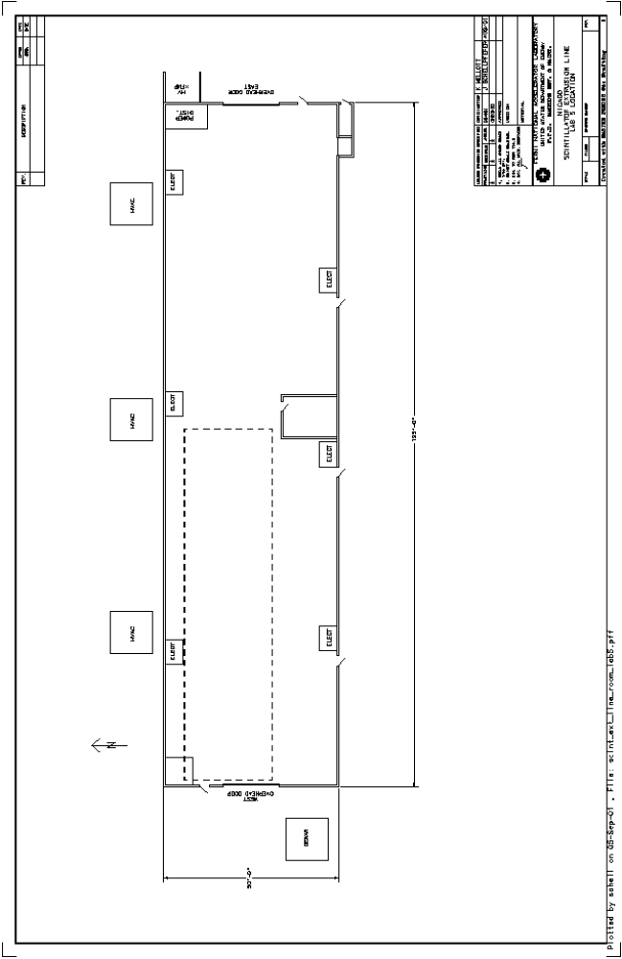

17. Appendix 6 – Lab 6 Extrusion Line Floor Plan
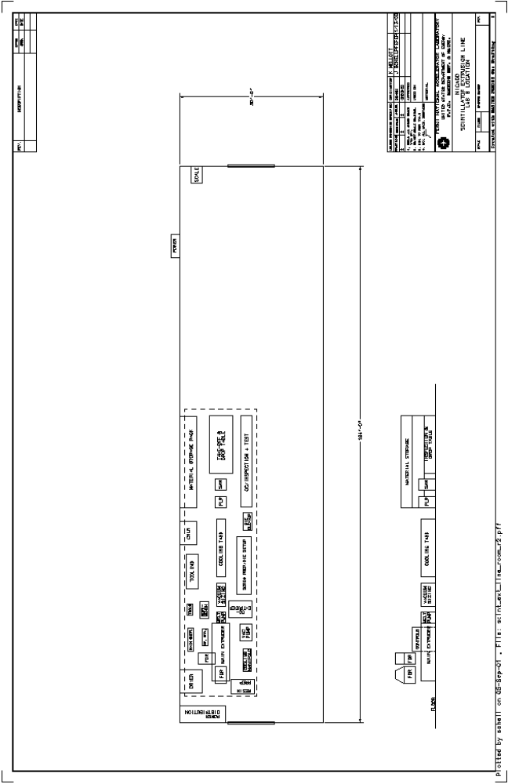

18. Appendix 7 – Lab 7 Extrusion Line Floor Plan
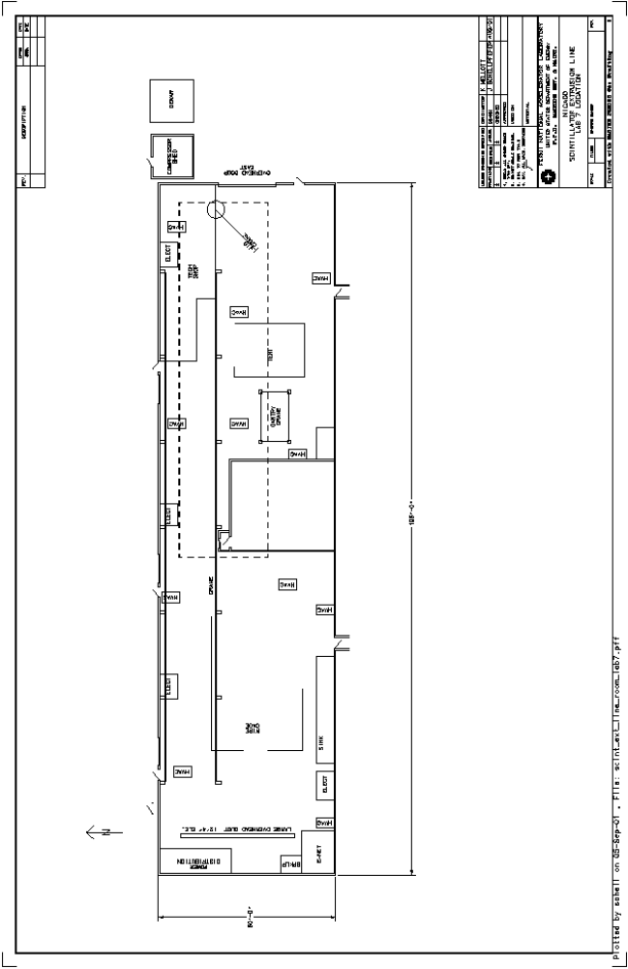

19. Appendix 8 – Extrusion Line Feeder end Elevation View

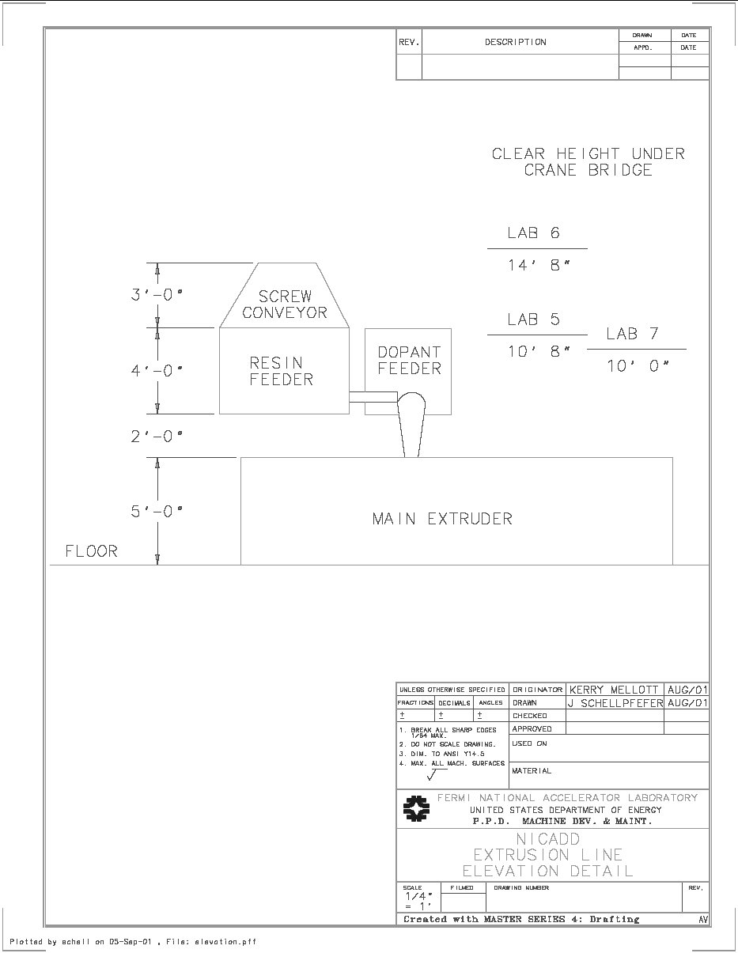

20. Appendix 9 – Full Extrusion Line Floor Plan



